**Karnataka Law Society’s**

**GOGTE INSTITUTE OF TECHNOLOGY**

**Udyambag, Belgaum – 590008**

A report submitted in fulfillment of requirements for 6th semester

B.E. (ECE) Course-Activity work

**“RISK MANAGEMNET OF COVID-19 ”**



Submitted by

**SHREEHARI D**

**(2GI17EC124)**

Under the guidance of

**Prof. Pratijnya Ajawan**

**(**Assistant Professor)

**DEPARTMENT OF ELECTRONICS AND COMMUNICATION ENGINEERING**

**Academic year 2019-2020 (Even Sem)**

**Karnataka Law Society’s**

**GOGTE INSTITUTE OF TECHNOLOGY**

**Udyambag, Belgaum – 590008**

**DEPARTMENT OF ELECTRONICS AND COMMUNICATION ENGINEERING**



**CERTIFICATE**

Certified that the course-activity work entitled **“Risk Management of COVID-19**” carried out by **SHREEHARI D**, USN: **2GI17EC124** a bonafide student of KLS Gogte Institute of Technology in partial fulfillment for the award of **Bachelor of Engineering** in **Electronics and Communication Engineering** of the Visvesvaraya Technological University, Belgaum during the year **2019-2020**. It is certified that all corrections/suggestions indicated for Internal Assessment have been approved as it satisfies the academic requirements in respect of subject course activity work prescribed for the said Degree.

**Guide Head of the Department**

**(Prof. Pratijnya Ajawan) (Dr. Santosh S Saraf)**

**Acknowledgement**

This subject course activity work consumed huge amount of work, research and dedication. The course activity would not have been possible if I did not have received support of many individuals and organizations for their incredible knowledge. Therefore I would like to extend my sincere gratitude to all of them. In particular, I would like to take this opportunity to express my honor, respect, deep gratitude & genuine regards to the staff of **KLS’s Gogte Institute of Technology, Belagavi (Department of Electronics and Communication Engineering)** for providing me all the guidance required for my mini-project.

I sincerely would like to thank my guide **Prof. Pratijnya Ajawan**  for guiding me throughout this course activity and also would like to thank my **Head of Dept** **Dr. Santosh. S. Saraf** for giving a platform to showcase my course activity.

My Sincere thanks to Principal, KLSGIT, Belagavi who have given me opportunity of doing this course activity.

Last but not the least I would like to thank all the people who have helped me directly and indirectly for making my course activity successful.

**SHREEHARI D**

**CONTENTS**

1. **Introduction**
2. **Algorithm**
3. **Code**
4. **Result screenshot**
5. **Advantages and Disadvantages**
6. **Conclusion**

* **Theory:**

An array of structures in C can be defined as the collection of multiple structures variables where each variable contains information about different entities .The array of structures in C are used to store information about multiple entities of different data types.The array of structures is also known as collection of structures.

**FILE:**

The C programming language provides many standard library functions for file input and output.These functions make up the bulk of the C standard library header <stdio.h>. The functionality

Descends from a “portable I/O package”.

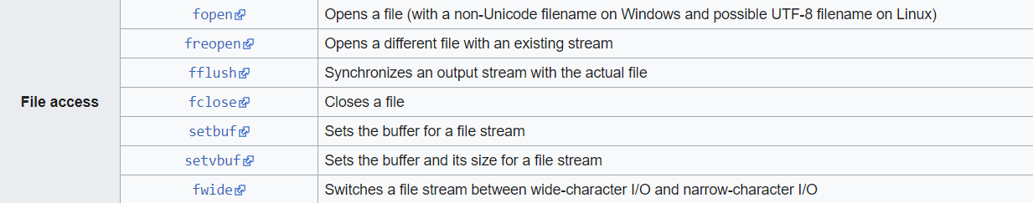

**ALGORITHM:**

Step 1:Declare the structure with object as name , id and Active,Risk.

Step 2: Input the name of the quarantined person by using for loop.

for(i=0;i<n;i++)

scanf(“%s”Name[i]);

Step 3: Input the id’s of the persons who got the positive report by loop.

for(i=0;i<m;i++) (where ‘m’ is number of positive cases)

if id matches with the id of the list.

Then

For that id Active=1;

Step 4: Then by comparing the “Active” value and by using the id the risk rate is displayed.

Example; if id=3 is positive then the risk for id=4 is given by

Risk=10-mod(3-4)*10 (“mod()” functions gives +ve number)

And risk for id 3 is given 100%

**CODE:**

#include<stdio.h>

#include<stdlib.h>

struct data{

int id;

char name[20];

int active;

int d;

}a[10],b[10];

int act[10],cas;

int active(void);

int cases(void);

int alert(void);

int main()

{ int i;

FILE *file;

file=fopen("test.txt","w+");

fprintf(file,"**********Quarantine Data**********\n");

fprintf(file,"ID\t\tName\t\tActive\n");

for(i=0;i<10;i++)

{

printf("%d)Enter th data:Name \n",(i+1));

a[i].id=i+1;

scanf("%s ",&a[i].name);

fprintf(file,"%d\t\t%s\t\t%d\n",a[i].id,a[i].name,a[i].active);

}

cases();

fprintf(file,"-*-*-*-*-*-*-*-*-*-*-*-*-*-*-*-*-*-*-*-*-*-*-*-*-*-*-*-");

fprintf(file,"\nID\t\tName\t\tActive\t\tRisk\n");

for(i=0;i<10;i++)

fprintf(file,"%d\t\t%s\t\t%d\t\t%d %%\n",a[i].id,a[i].name,a[i].active,a[i].d);

fprintf(file,"-*-*-*-*-*-*-*-*-*-*-*-*-*-*-*-*-*-*-*-*-*-*-*-*-*-*-*-");

fclose(file);

}

int cases()

{

int i;

printf("How many active cases found:");

scanf("%d",&cas);

printf("Enter the ID of active people:");

for(i=0;i<cas;i++)

{

scanf("%d",&act[i]);

}

active();

alert();

return 0;

}

int active()

{

int i;

for(i=0;i<cas;i++)

{

a[act[i]-1].active=1;

}

return 0;

}

int alert()

{

int i,j,l;

for(i=0;i<cas;i++)

{

for(j=0;j<10;j++)

{

l=10-abs(act[i]-a[j].id);

if(a[j].d<l*10)

a[j].d= (l)*10;

}

}

}

**RESULT SCREENSHOT:**

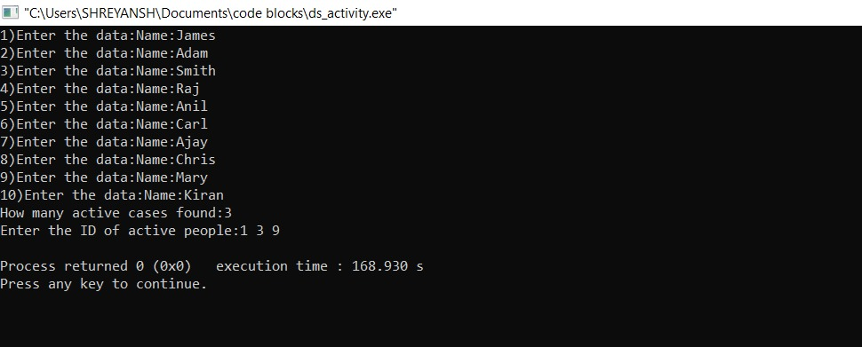

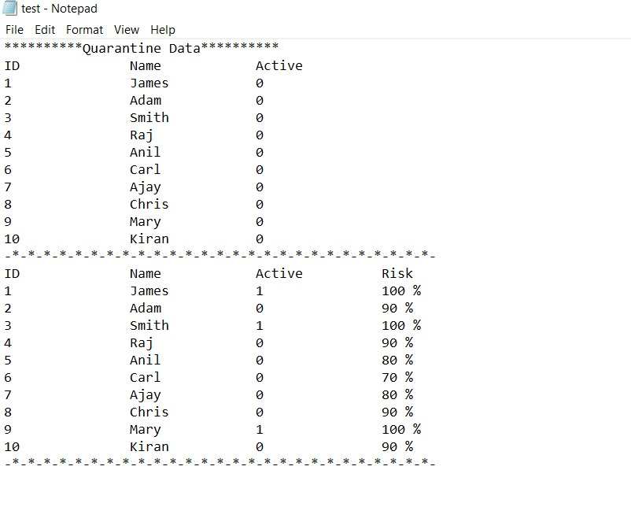

**ADVANTAGES:**

1)creates quarantine date with respect to risk factor in terms of percentage.

2)helps us to categorize individuals into different groups in file format.

**DISADVANTAGES:**

1. It only helps to find the risks for one person who contacted with the other people.

**CONCLUSION:**

The following code when used in a program helps us to assess the risk for individuals who came in contact with positive case and also the individuals whom he may further come in contact. By grouping the individuals into risk factor and creating proper data.